Lab safety Make Up Work (2 pages)
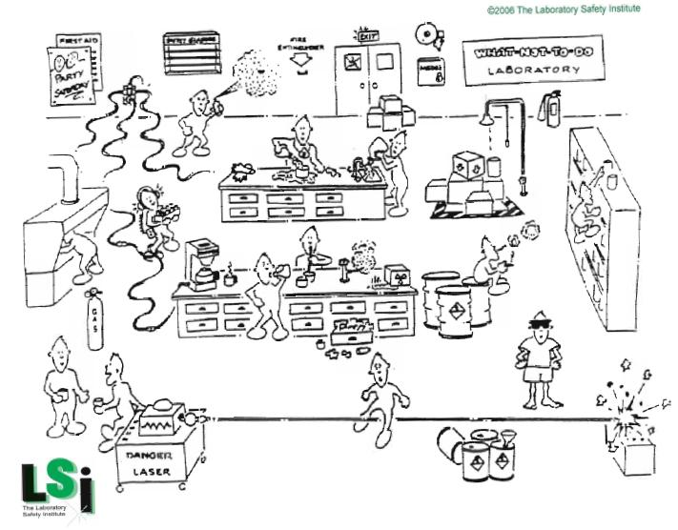
Look at the scene below. Circle and describe as many potential problems as possible.

YouTube the following Video: Zombie College: The 5 Rules of Lab Safety
https://www.youtube.com/watch?v=S6WARqVdWrE
List the 5 Rules that were described in the Video:
1
2
3
4
5

